Original article

Comparison of mast cell count in oral reactive lesions:
A histochemical study
¹Dr. Shreya Thakkar , ²Dr. Dhruval Acharya ,³Dr. Sima Odedra
QR Code: Scan Here
1. Post-graduate student, Department of Oral Pathology.
2. Post-graduate student, Department of Oral Pathology.
3. Assistant Professor, Department of Oral Pathology.
Department of Oral Pathology, Govt Dental College and Hospital, Ahmadabad, Gujarat
Corresponding author: Dr. Shreya Thakkar

ABSTRACT
Reactive hyperplastic lesions are one of the most common lesions of the oral cavity. Mast cells can be found in various oral lesions. Aim of this study was to compare the mast cells count in various oral reactive lesions with normal mucosa. Material and Method: study was performed on samples of oral reactive lesions including irritation fibroma (IF), pyogenic granuloma (PG), peripheral giant cell granuloma (PGCG) and peripheral ossifying fibroma (POF). To determine the mast cells count 1% toluidine blue staining was performed. Statistical analysis was applied to see the significant differences between the groups. Results: In this study, mast cell count was maximum in POF and IF followed by cases of PG and PGCG. Conclusion: mast cells may have a role in the pathogenesis of the oral reactive lesions and induction of fibrosis.
Key words: mast cells, toluidine blue, irritation fibroma (IF), pyogenic granuloma (PG), peripheral giant cell granuloma (PGCG) and peripheral ossifying fibroma (POF), fibrosis
INTRODUCTION
Oral mucosa is constantly subjected to external and internal stimuli and therefore manifests a spectrum of diseases that range from developmental, reactive and inflammatory to neoplastic. Reactive hyperplastic lesions represent the most frequently encountered oral mucosal lesions in humans. These lesions represent a reaction to some kind of irritation or low grade injury such as chewing, trapped food, calculus, fractured teeth and iatrogenic factors including overextended flanges of dentures and overhanging dental restorations. Kfir et al. have specifically classified reactive hyperplastic lesions into pyogenic granuloma (PG), peripheral giant cell granuloma (PGCG), peripheral ossifying fibroma (POF) and irritation fibroma (IF).[1][5] Mast cells (MCs) are mobile, bone marrow-derived, granule containing immune cells.They circulate within peripheral blood, and mature forms are widespread; they are found in all connective tissue and mucosal environments, particularly in perivascular areas, as well as in the peripheral and central nervous system . These cells have a primary role in hypersensitivity reactions and inflammatory processes . In addition, there is evidence that MCs play a role in matrix and granulation tissue formation, wound healing, angiogenesis ,and remodelling. Many studies have shown the interaction of mast cells with fibroblasts and their contribution to collagen synthesis in many diseases and pathological conditions, such as scleroderma ,fibrosis of skin , appendix , lung and kidney , and also their association in oral submucous fibrosis , gingival fibromatoses , and fibrotic changes in minor salivary glands of patients with Sjogren’s syndrome .[2]

AIM
The Aim of this study was to evaluate the mast cells (MCs) count in oral soft-tissue reactive lesions including peripheral giant cell granuloma (PGCG), peripheral ossifying fibroma (POF), fibrous hyperplasia (FH), Pyogenic granuloma (PG) and compare mast cell counts with normal oral mucosa.
OBJECTIVE
The objective of this study was to determine role of mast cells in pathogenesis of different oral reactive lesions and to correlate presence of mast cells with state of connective tissue changes in reactive lesions.
MATERIALS & METHODS
In present study, samples were taken from the archives of oral pathology and microbiology department, Govt Dental College, Ahmedabad. Samples included are cases of irritation fibroma (IF), pyogenic granuloma (PG), peripheral giant cell granuloma (PGCG), peripheral ossifying fibroma (POF). After reviewing the histological slides, 5 cases were selected for each category. As controls Clinically normal oral mucosa tissue specimens were obtained from those who had surgical removal of impacted tooth. All the samples were stained with 1% toluidine blue for mast cells.1% toluidine blue solution contained 0.2g toluidine blue in 100ml of distilled water and 2ml of acetic acid. Because sulfated proteoglycans in secretory granules of mast cells have a metachromatic property that can be stained by toluidine blue. Mast cells were counted in 10 high power fields (X400) where the highest number of mast cells was seen. Data were analysed statistically using One-way ANOVA-F and unpaired t-test.[1]

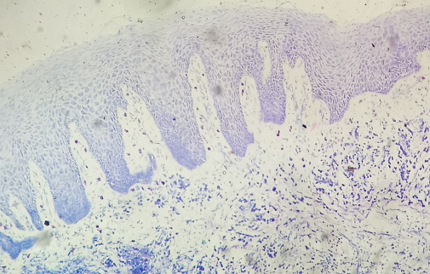
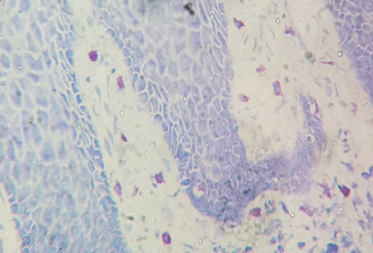

Figure 1 mast cells stained with toludine blue-showing metachromatic granules

RESULTS
The findings of study were as follows.
The average no. of mast cells in normal mucosa was 7.40. Highest no. of mast cells were seen in POF 81.40 and lowest no. of mast cells were seen in PGCG 34.80. Table 1 shows mean and standard deviation of mast cells based on the type of lesions. Table 2 shows comparisons of mast cell count with normal gingiva using unpaired t test. Table 3 shows one-way ANOVA -F test for significant difference among mast cell counts.

GROUP | NORMAL | POF | IF | PG | PGCG
MEAN | 7.40 | 81.40 | 60.20 | 35.60 | 34.80
SD | 1.14 | 54.04 | 32.13 | 3.21 | 17.71
SEM | 0.51 | 24.17 | 14.37 | 1.44 | 7.92
N | 5 | 5 | 5 | 5 | 5

Table 1: Mean and SD of different mast cell counts

Comparisons of normal gingiva with | P value of Unpaired t test
POF | 0.0155
IF | 0.0063
PG | 0.0001
PGCG | 0.0087

Table 2: Comparisons of different mast cell counts with normal gingiva using unpaired t-test

SOURCE | SS | Df | MS | F | P value
Between- groups | 15779.44 | 4 | 3944.86 | 4.61139 | 0.008416
Within- groups | 17109.2 | 20 | 855.46
Total | 32888.64 | 24

Table 3: One-way ANOVA-F table for significant difference among mast cell counts

DISCUSSION
In this study, mast cells count was compared in selected oral soft tissue reactive lesions. In our study, the MC count in reactive lesions were increased in number compared to healthy gingiva. According to the results of our study the MC count in cases of peripheral ossifying fibroma (POF) and fibrous hyperplasia (FH) were significantly higher than in cases of pyogenic granuloma (PG) peripheral giant cell granuloma (PGCG). Mast cells exert their influence locally and systemically by releasing a variety of potent mediators through degranulation.[2] Many of these mediators are stored within cytoplasmic granules (preformed mediators) while others are produced at the time of mast cell stimulation.[2]
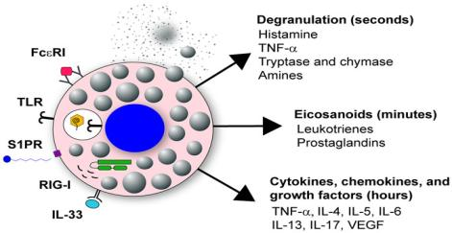

Figure 2 Showing release of mediators from mast cells

Histopathology of oral reactive lesions usually consists of neovascularization and inflammation depending on the stage of the lesion. Since mast cells contain cytokines that can bring about these actions, their presence in these lesions might help us to have a better understanding of the pathogenesis behind these lesions. One of the main components present inside secretory granules of mast cells is Tryptase. Tryptase has been shown to be involved in diverse biological activities such as fibrinogenesis, degradation of vasoactive intestinal peptide and stimulation of proliferation of fibroblast and smooth muscle cells. In addition, tryptase may stimulate the synthesis of collagen and contribute to angiogenesis.[1]

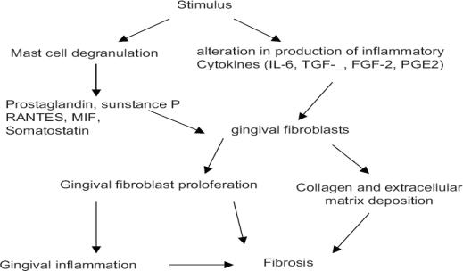

Figure 3 Showing pathogenesis of fibrosis in oral reactive lesions

MCs are reported to accelerate the migration and proliferation of fibroblasts in vitro. In fact, MCs can affect the fibroblast’s functional behaviour and consequently, the fibrosis process by releasing pre-formed mediators, such as histamine, proteoglycans, proteolytic enzymes, newly formed mediators, and fibrogenic cytokines like platelet derived growth factor (PDGF), tumor necrosis factor-a (TNF- a) and basic fibroblast growth factor (b-FGF).[2]
CONCLUSION
Based on the above findings, It can be concluded that MCs may play some roles in the formation of fibrocollagenous stroma of some oral soft-tissue reactive lesions and may be one of the factors responsible for the variation of microscopic features in such lesions with a common etiologic factor. Further studies on larger samples are recommended.

ACKNOWLEDGEMENT: Author would like to acknowledge Dr. Jyoti Chawda.

REFERENCES
1)Vandana Reddy, Sundeep S. Bhagwath, and Munish Reddy Mast cell count in oral reactive lesions: A histochemical study Dent Res J (Isfahan). 2014 Mar-Apr; 11(2): 187–192.
2)Farahani SS, Navabazam A, Ashkevari FS. Comparison of mast cells count in oral reactive lesions. Pathol Res Pract. 2010;206:151–5.
3)Molouk Torabi Parizi, Mehrnaz Karimi Afshar, Maryam Rad, Ali Taheri and Ramin Afshar Manesh An investigation on mast cells count in oral reactive lesions ISSN: 2347-3215 Volume 3 Number 8 (August-2015) pp. 1-6
4)Setareh Shojaei, Shokoofeh Jamshidi, Ghodratollah Roshanaei, Shirin Modabbernia, and Bahman Farzin Immunohistochemical Expression of Mast Cell in Oral Reactive Lesions. J Dent (Shiraz). 2015 Mar; 16(1 Suppl): 10–14.
5) Hamideh Kadeh, Ghazal Derakhshanfar, Shirin saravani Comparative Study of Mast Cell Count in Oral Reactive Lesions and Its Association with Inflammation(Turk Patoloji Derg 2016, 32:22-26)
6) Reet Kamal, Parveen Dahiya, Niti Goyal, Mukesh Kumar, Neeta Sharma, Hans Raj Saini Mast cells and oral pathologies: A ReviewJ Nat Sci Biol Med. 2015 Jan-Jun; 6(1): 35–39

